DBMS ASSIGNMENT 3 COLLEGE DATABASE

1. SHOW HOW TO CREATE AND DROP DATABASE .

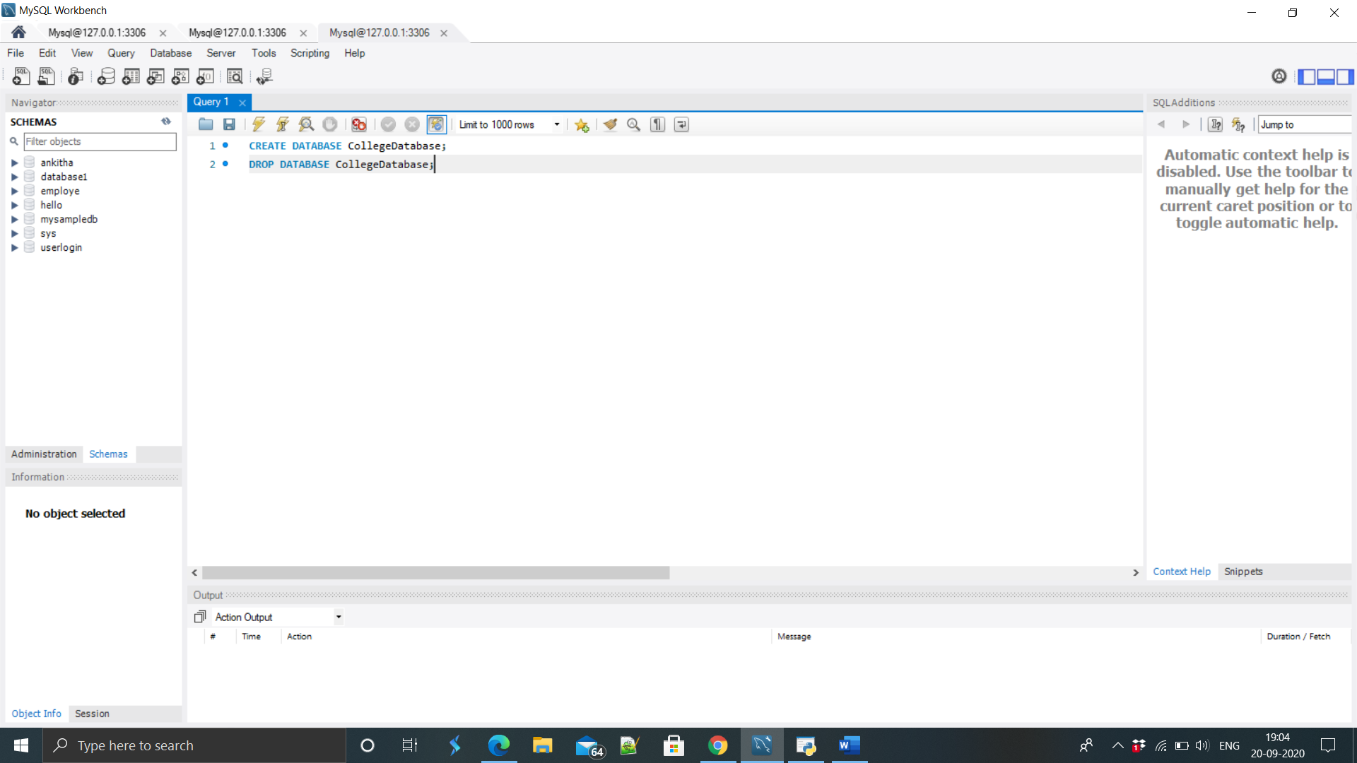

OUTPUT :

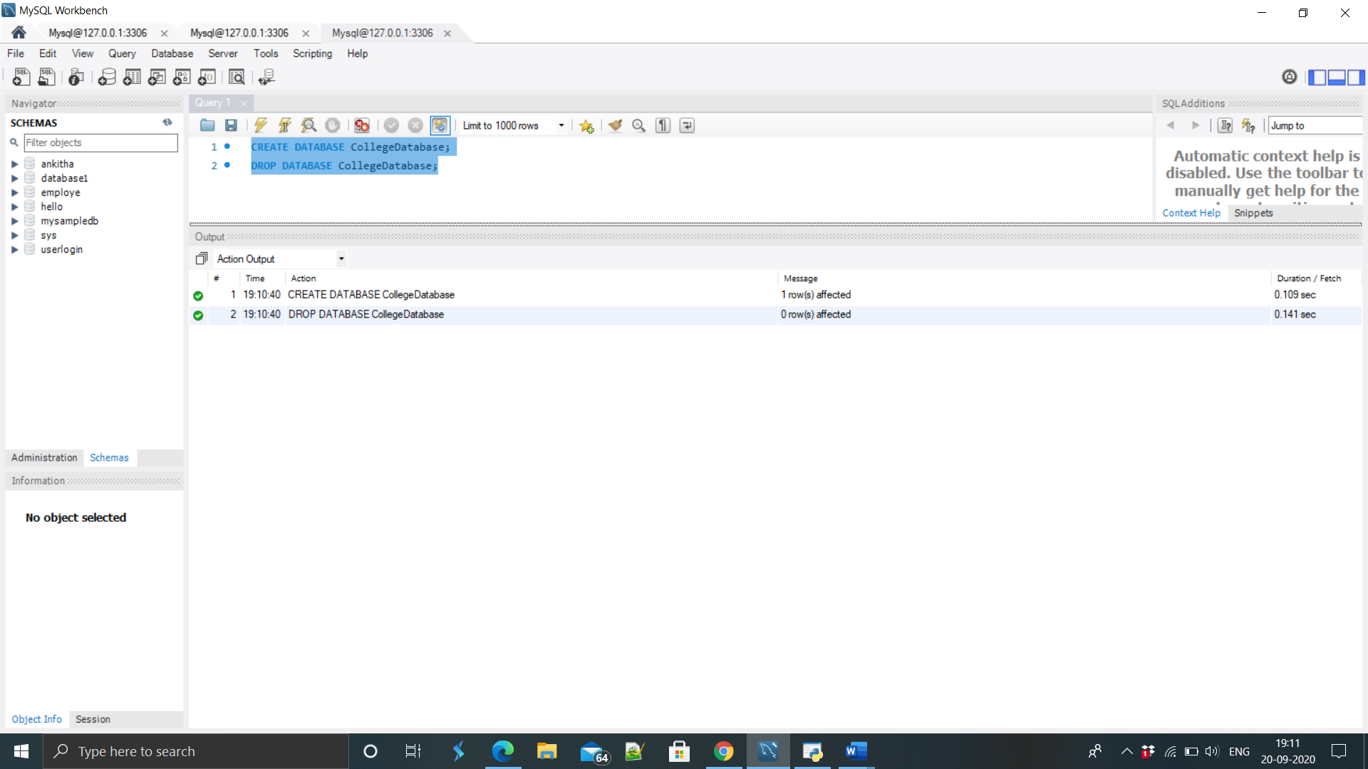

1. Show all the Databases are in the system.

QUERY :

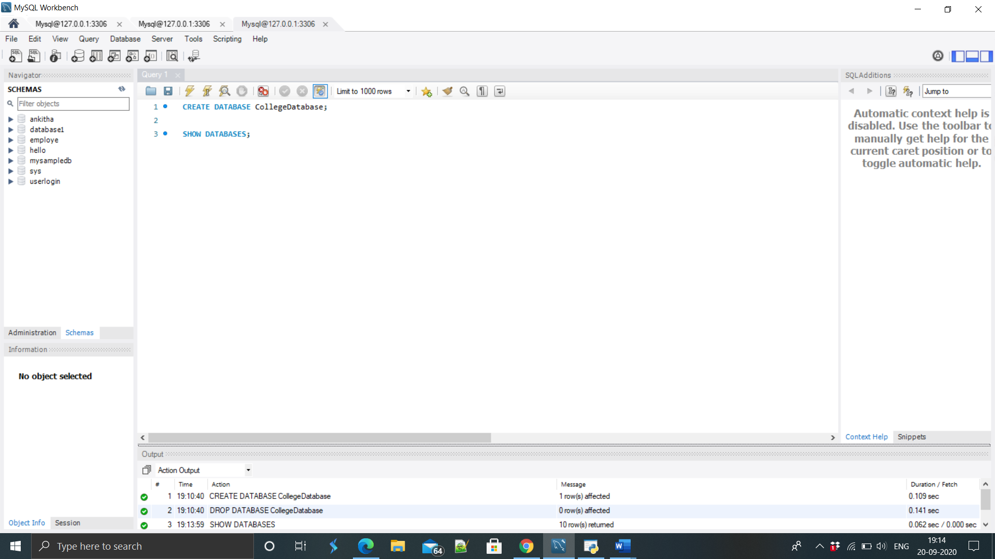

OUTPUT :

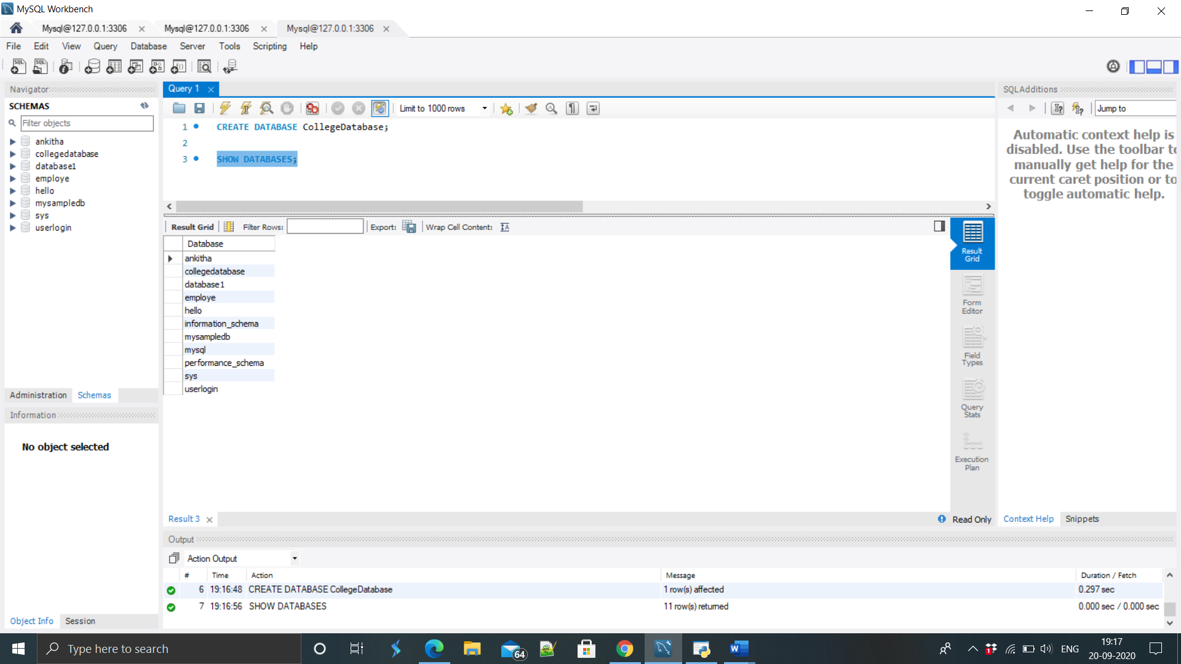

1. Create Table for your Database.

QUERY:

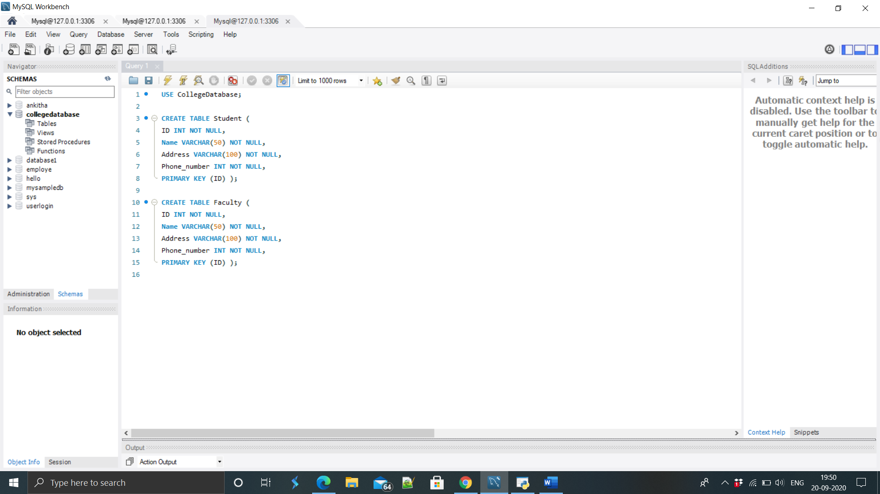

OUTPUT :

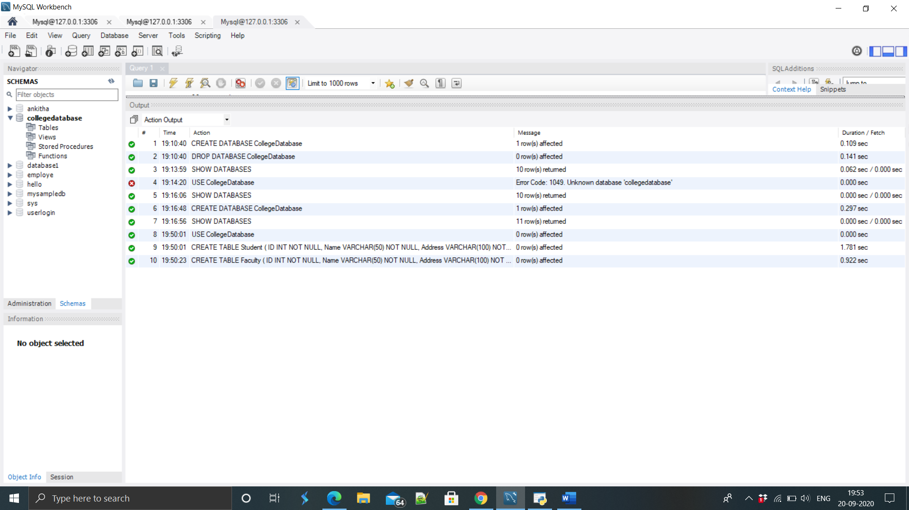

1. Show how select can be used for Creating table

QUERY:

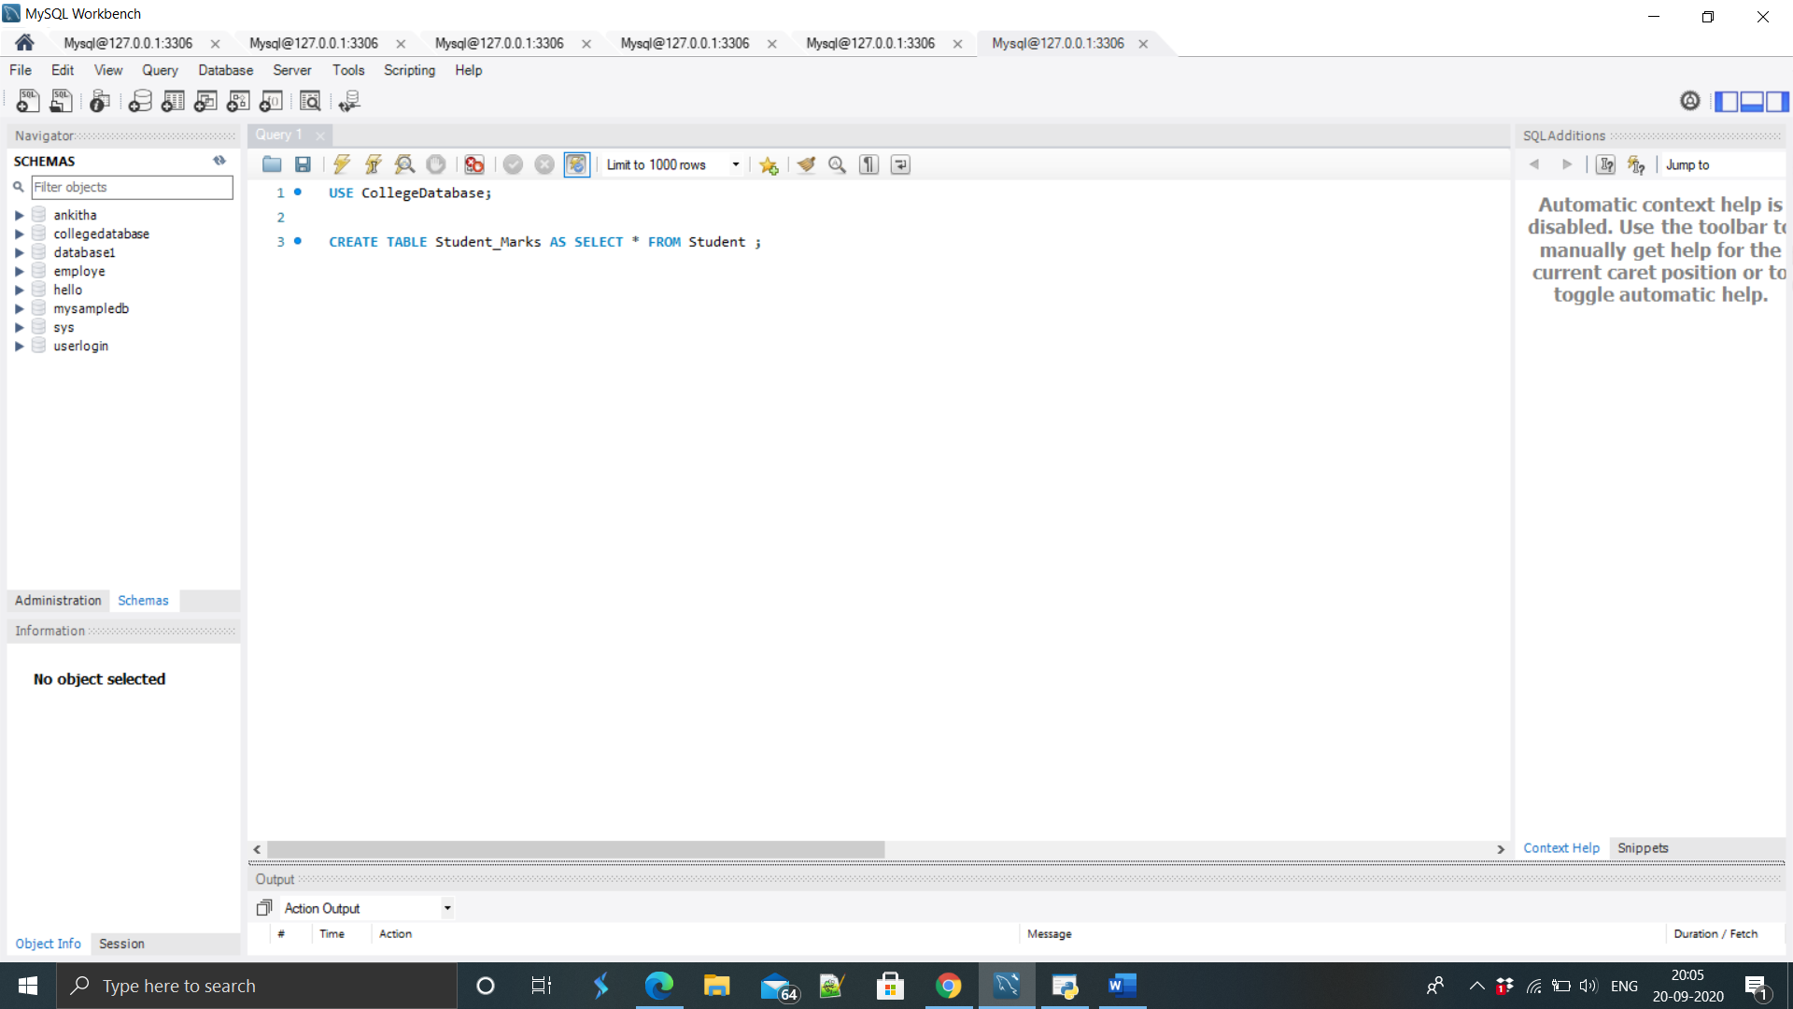

OUTPUT :

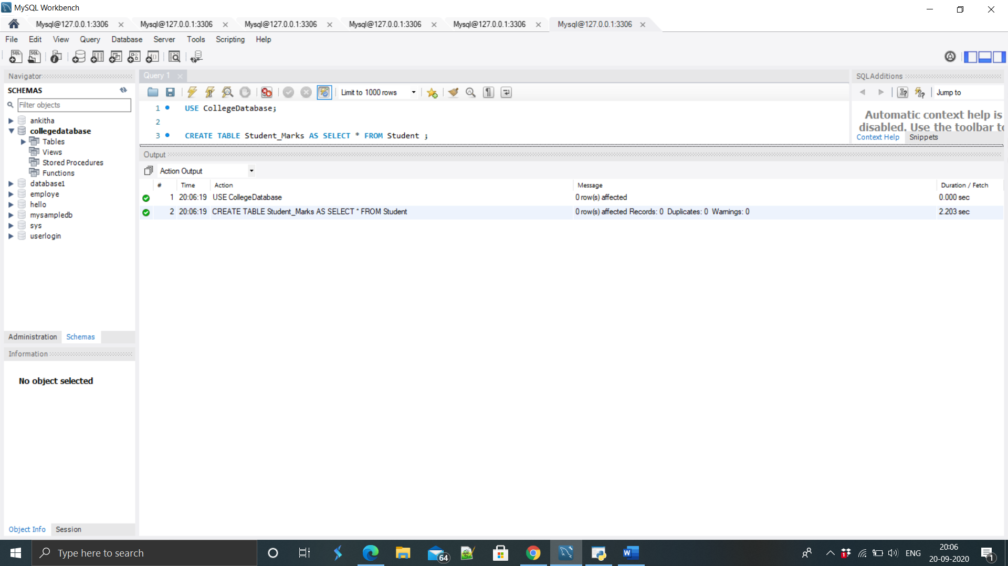

1. Drop table.

QUERY :

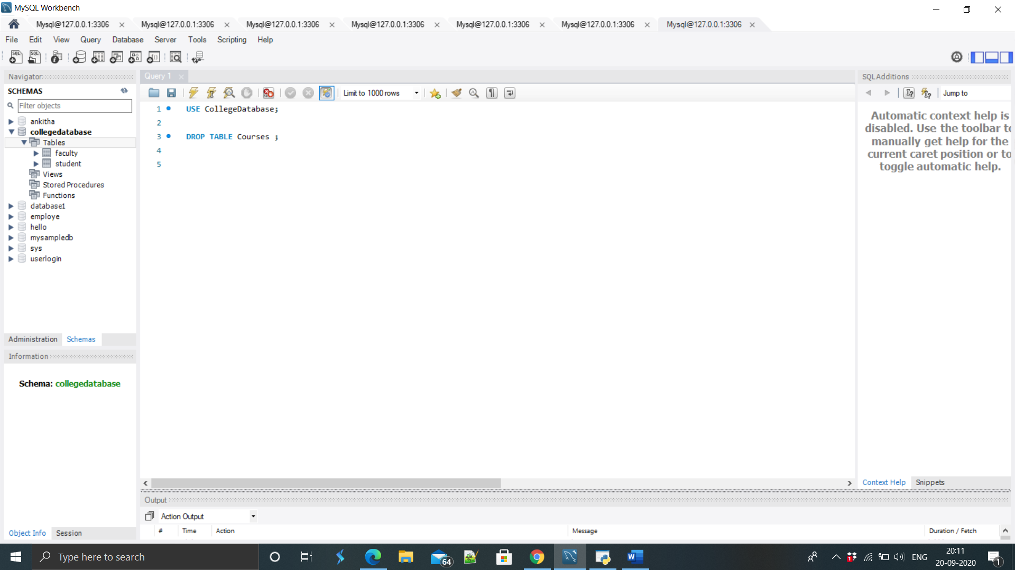

OUTPUT :

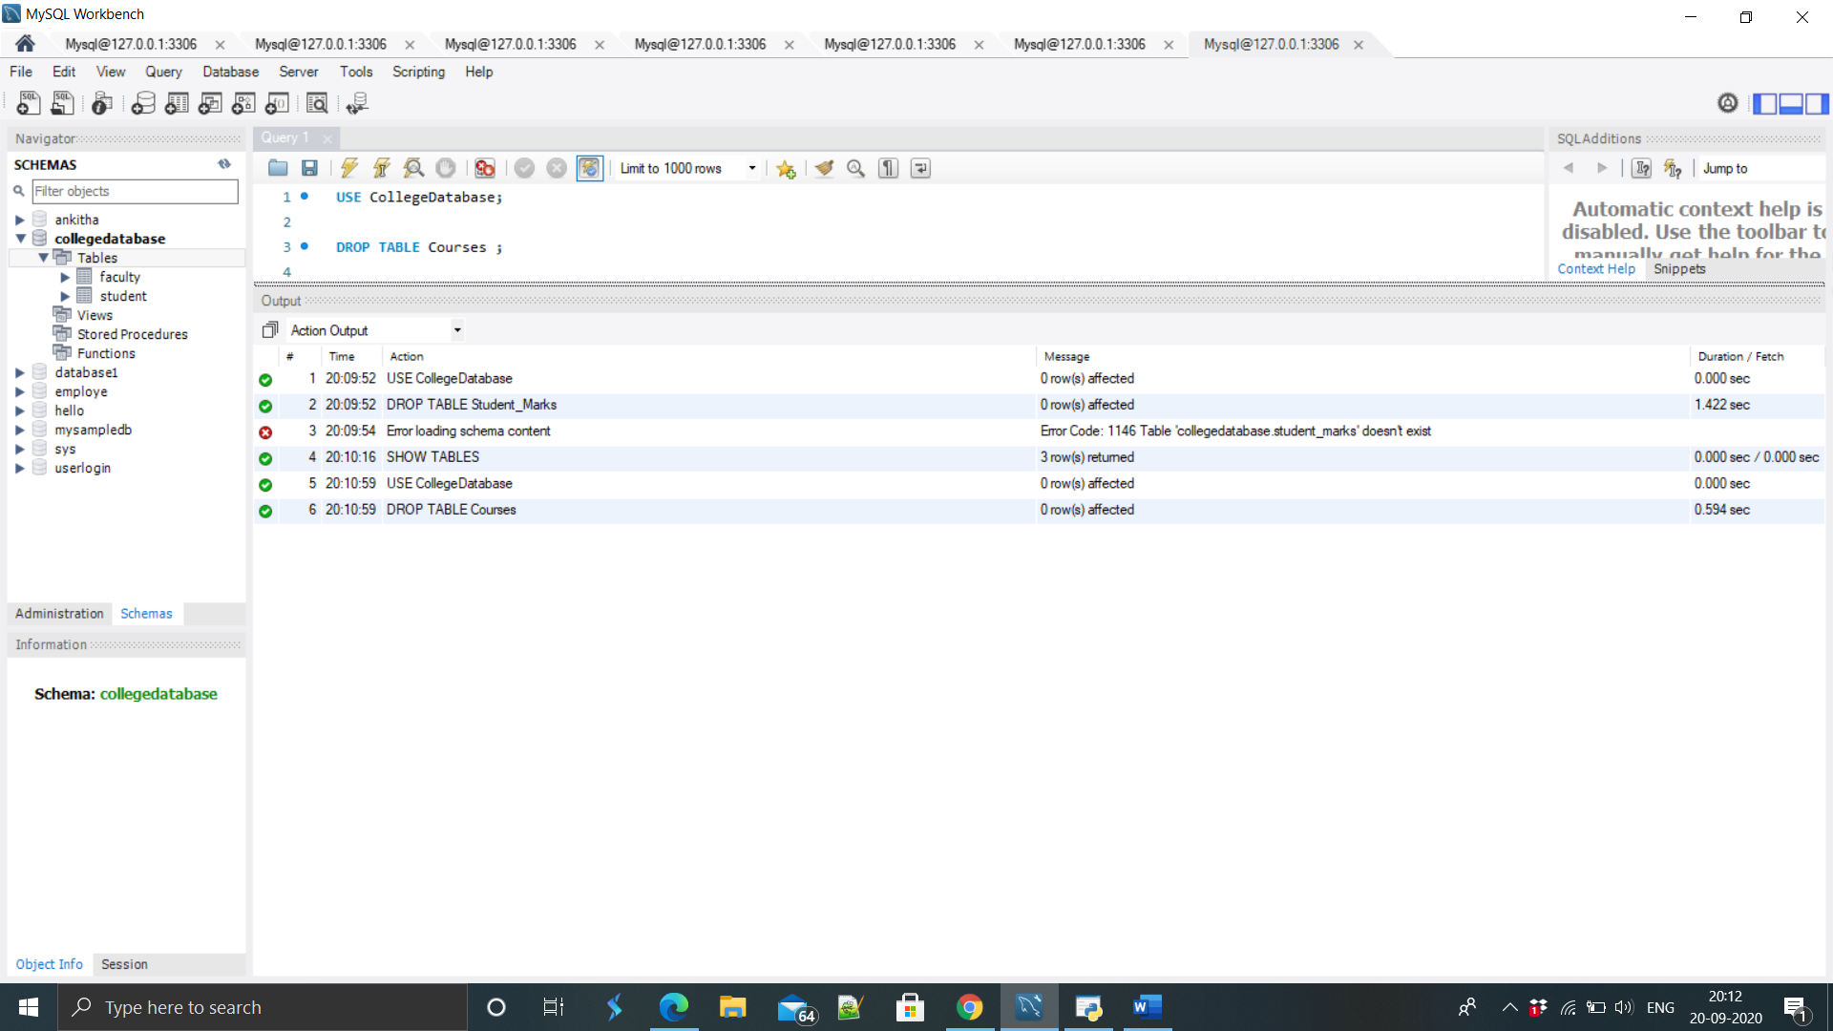

1. Show how to check the schema of the tables.

QUERY :

OUTPUT:

1. Show all the tables from the database.

QUERY :

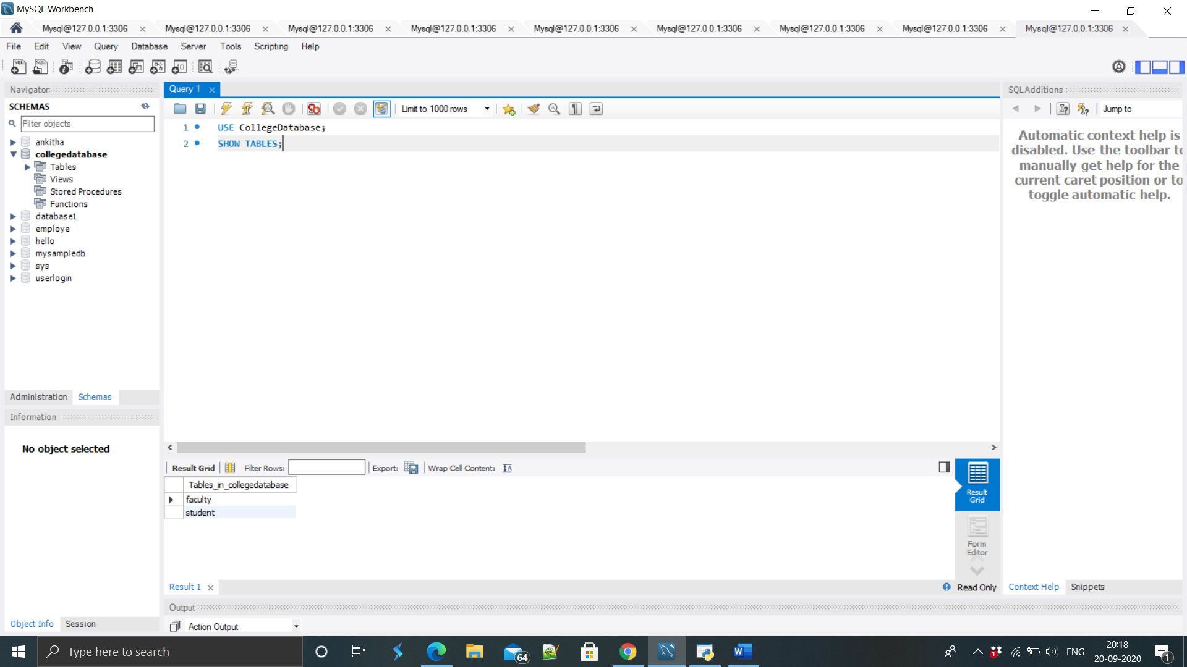

OUTPUT :

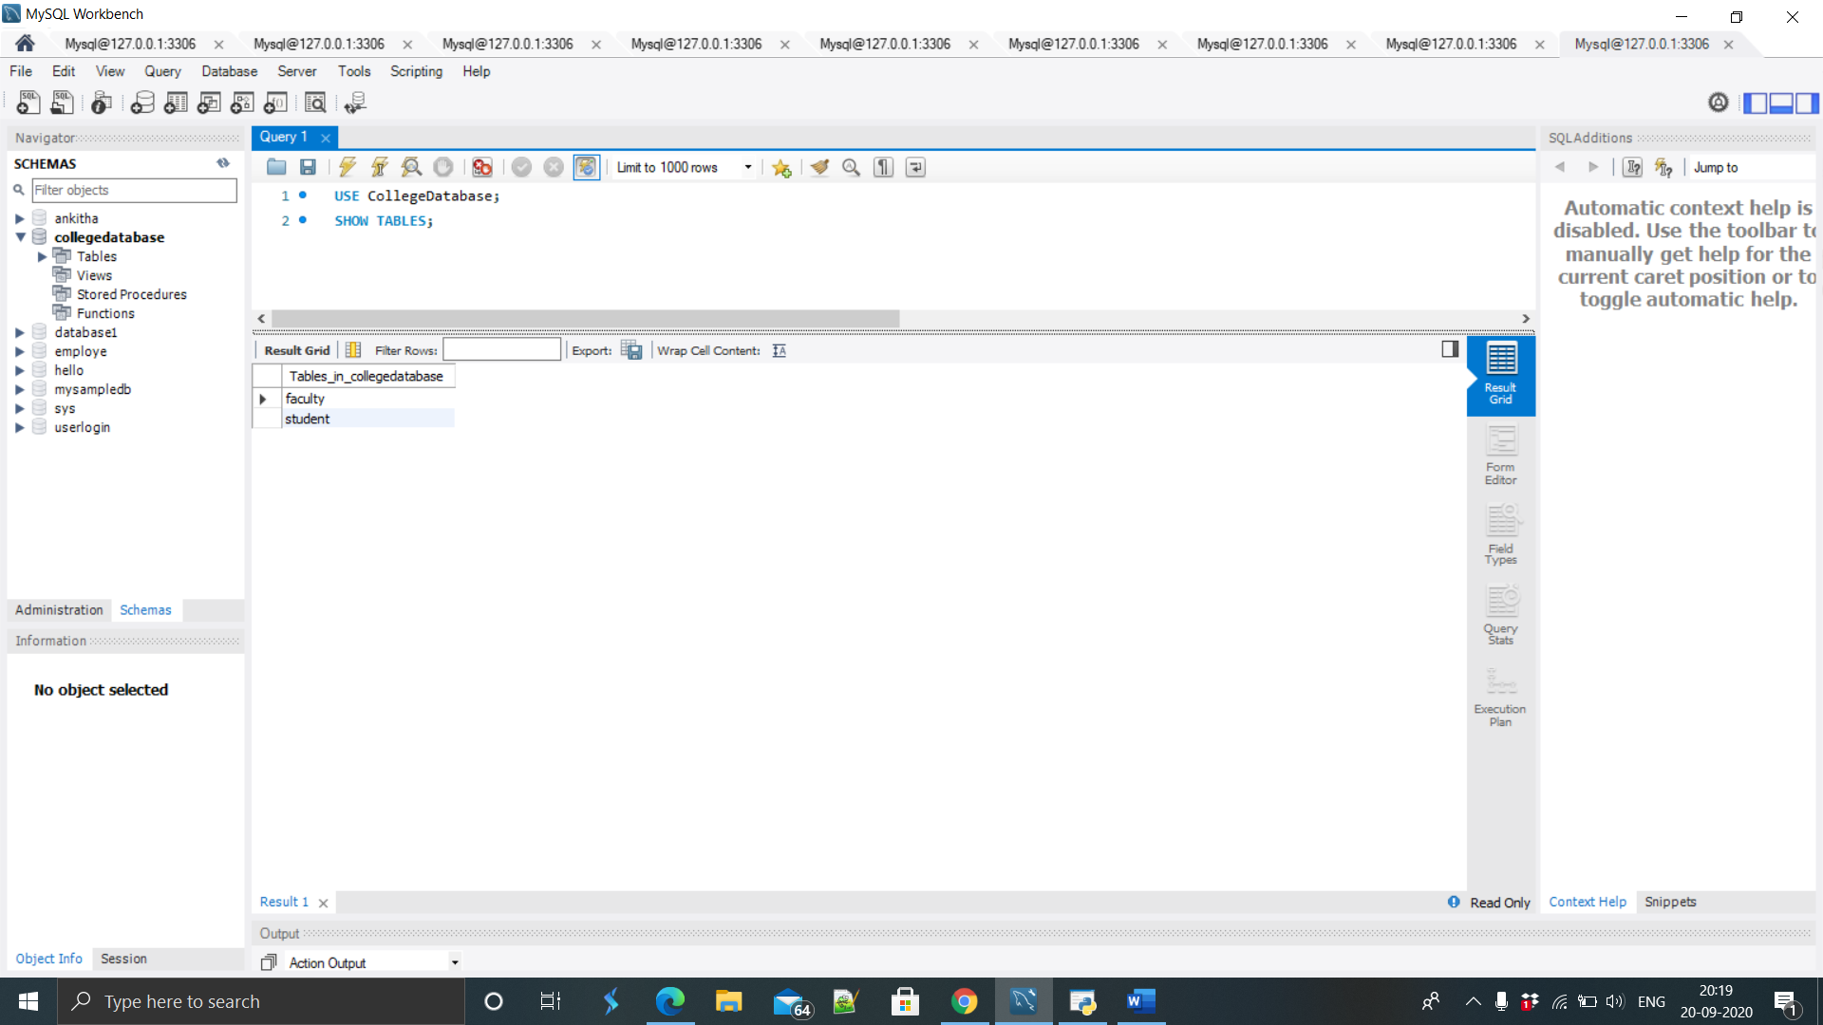

1. Insert 5 to 10 rows in each of the tables of your Database.

QUERRY :

Faculty:

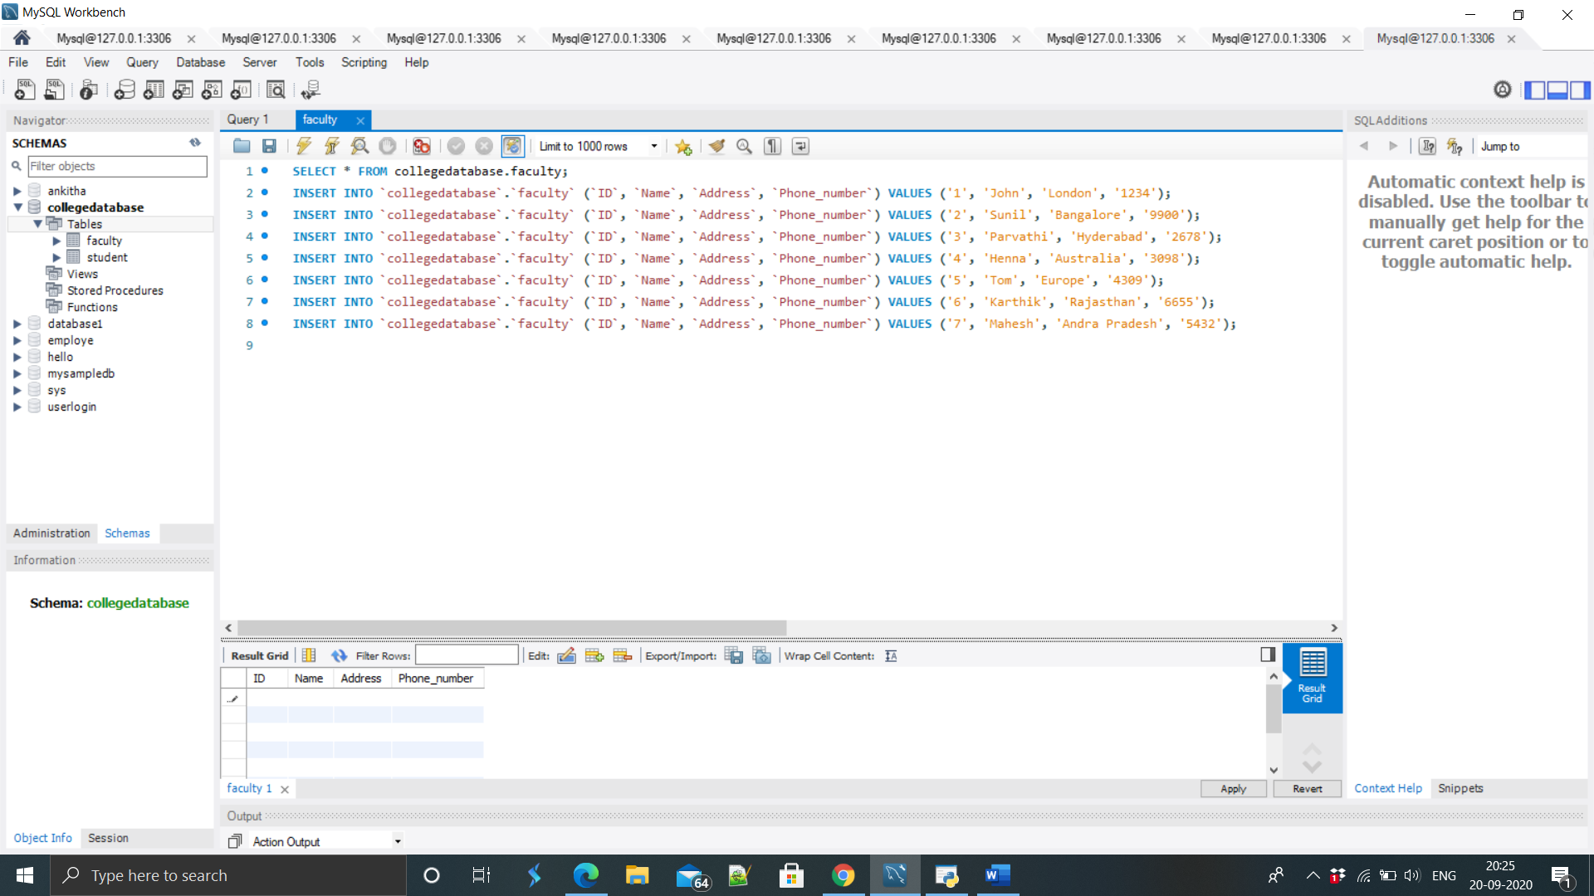

Students:

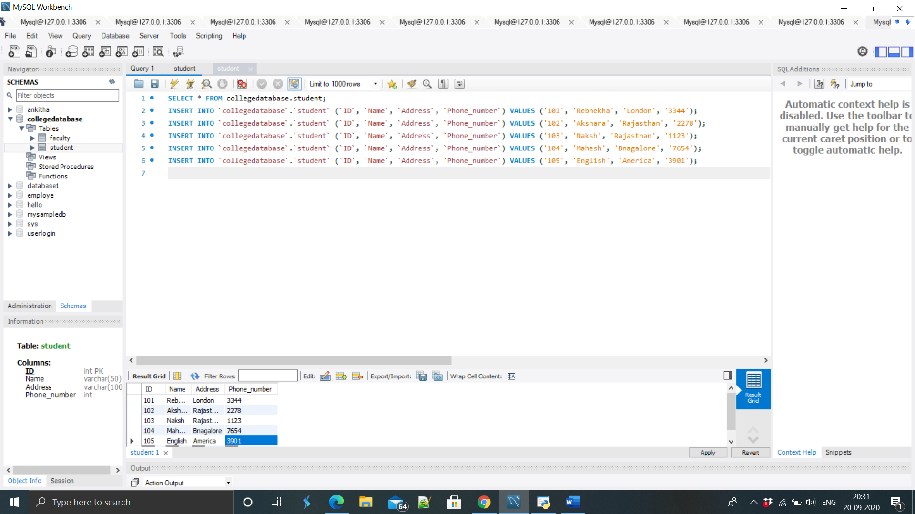

OUTPUT: Faculty:

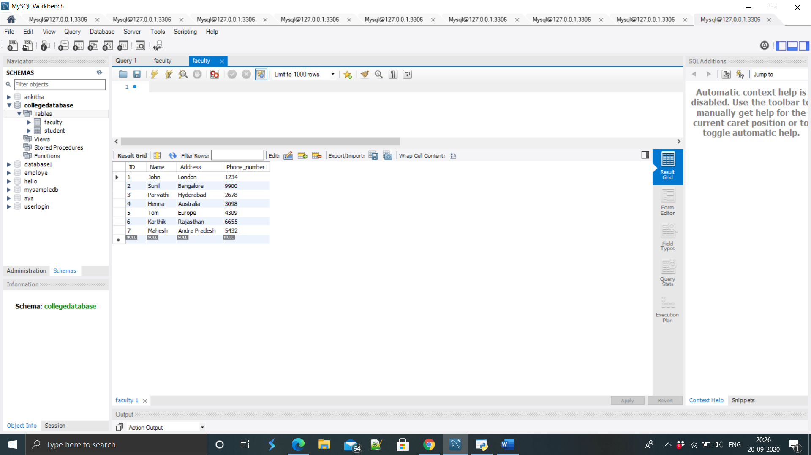

Students:

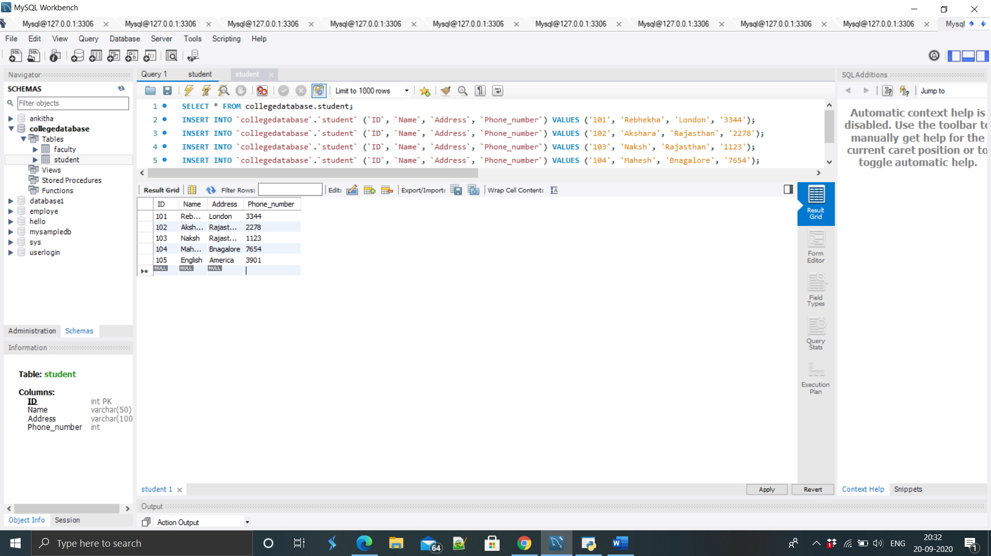

1. Show usage of Simple Select Statement.

QUERRY :

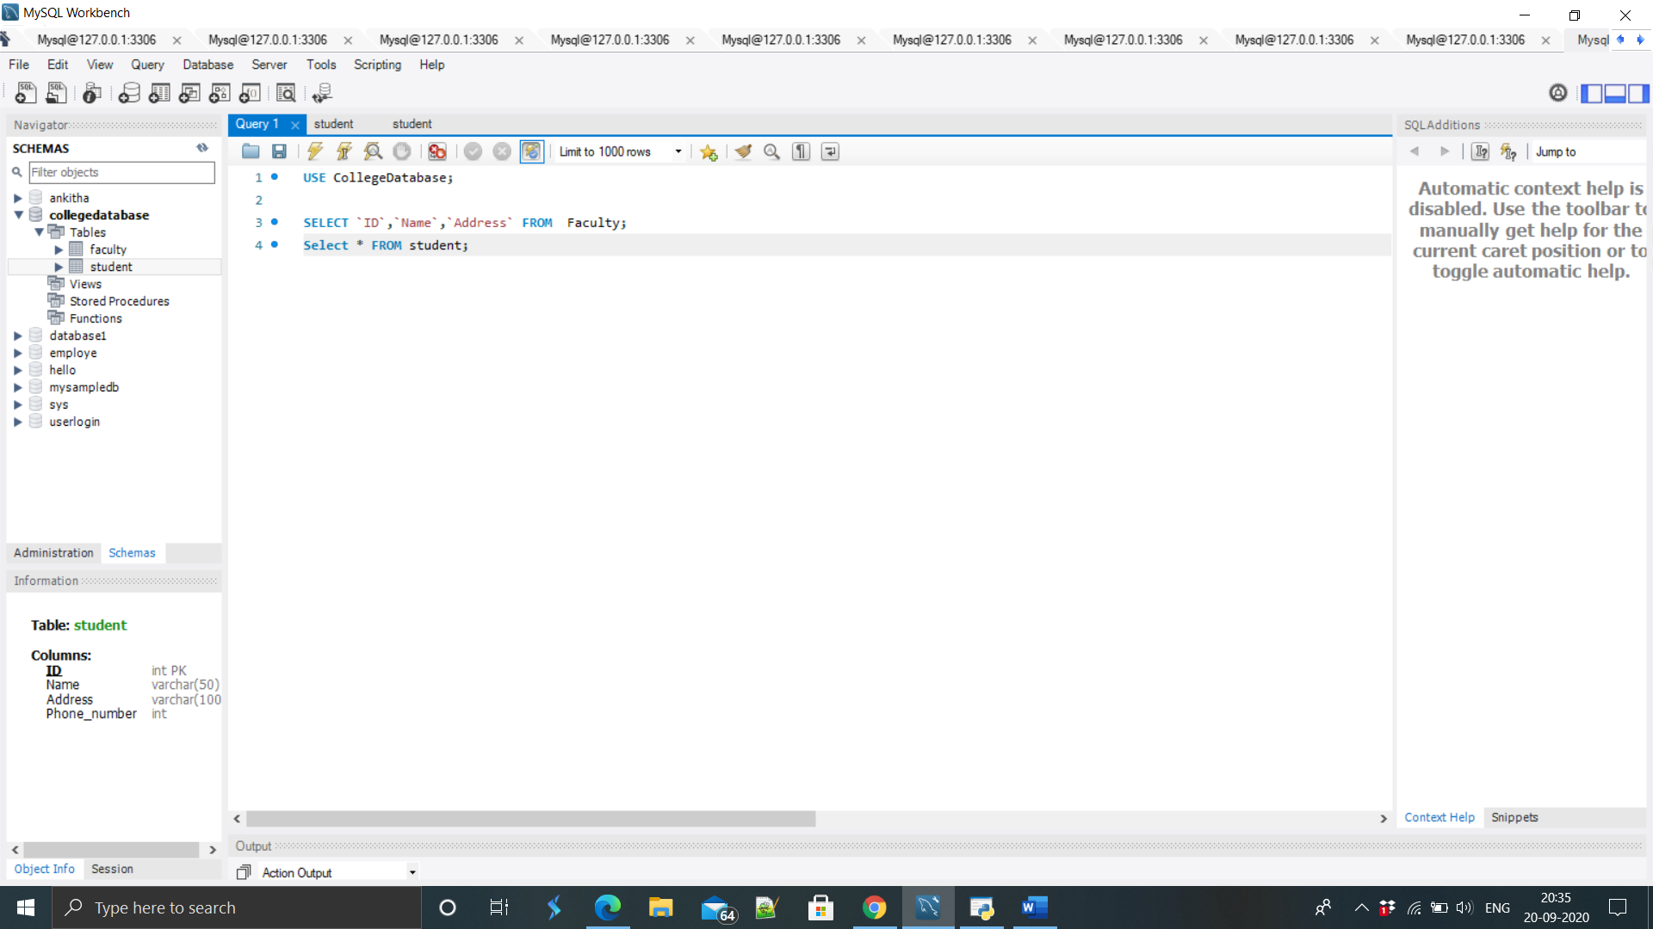

OUTPUT : Faculty :

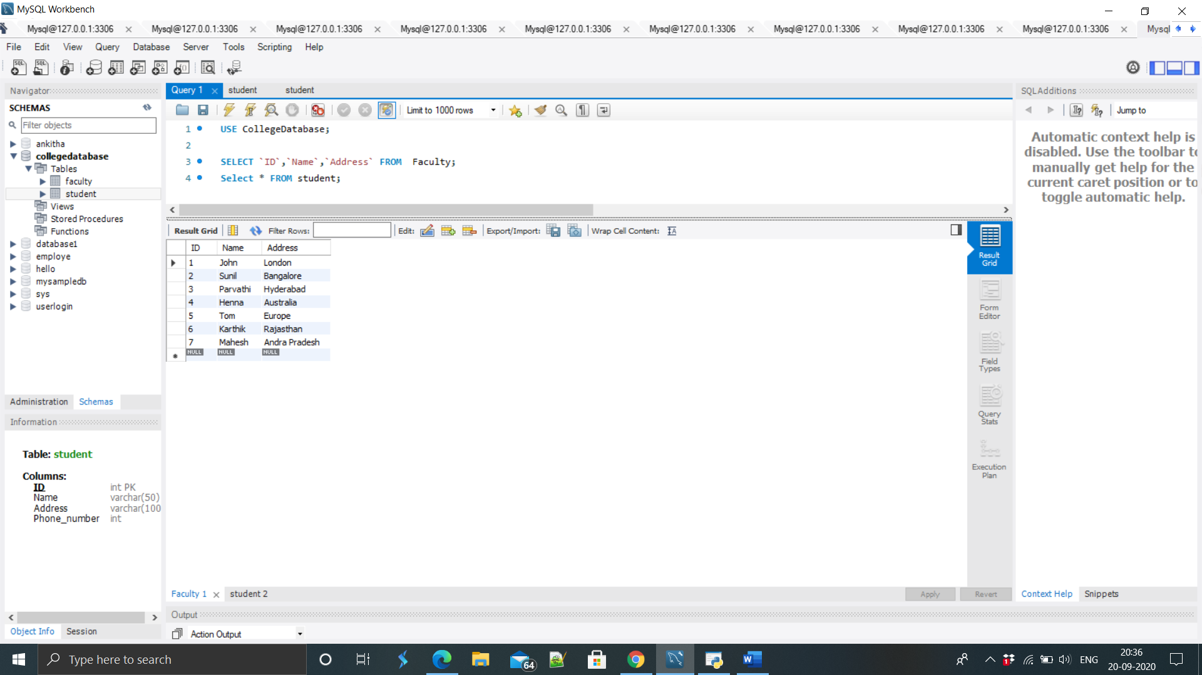

Student:

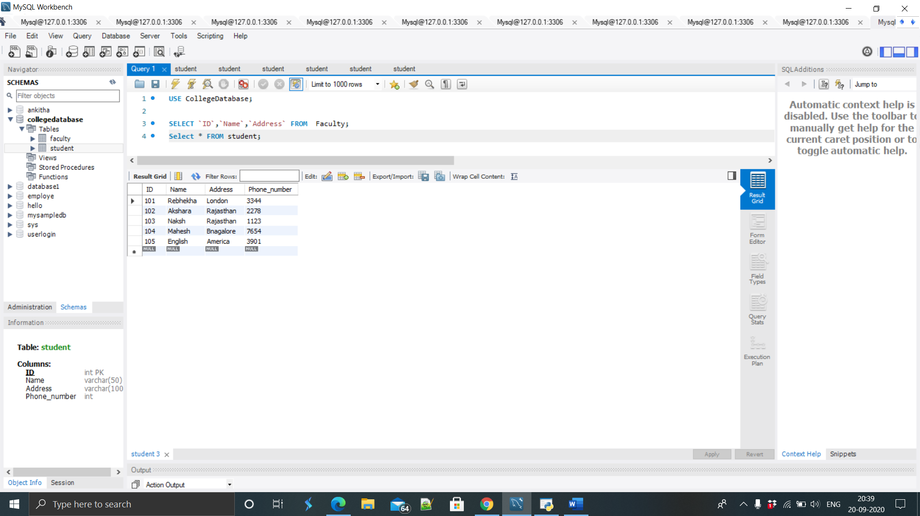

10 .Select Statement using Relational and Logical operators.

QUERRY :

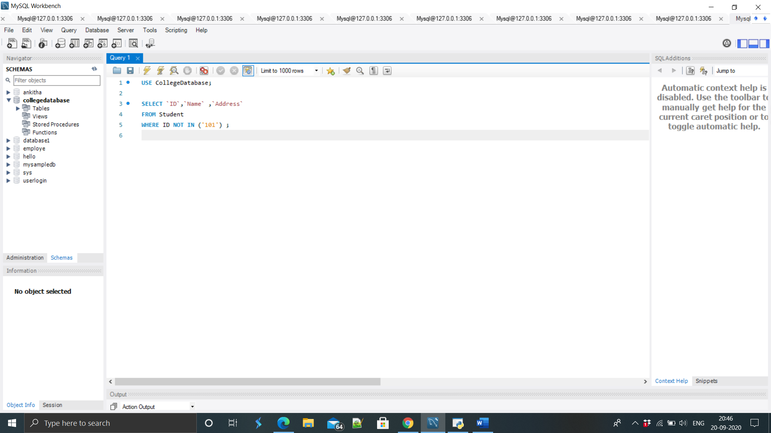

OUTPUT :

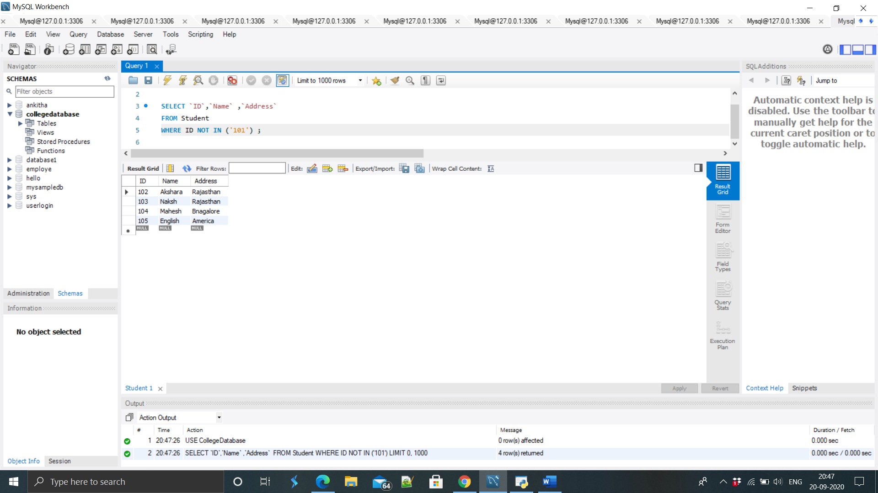

1. One simple Subquery using select.

QUERY :

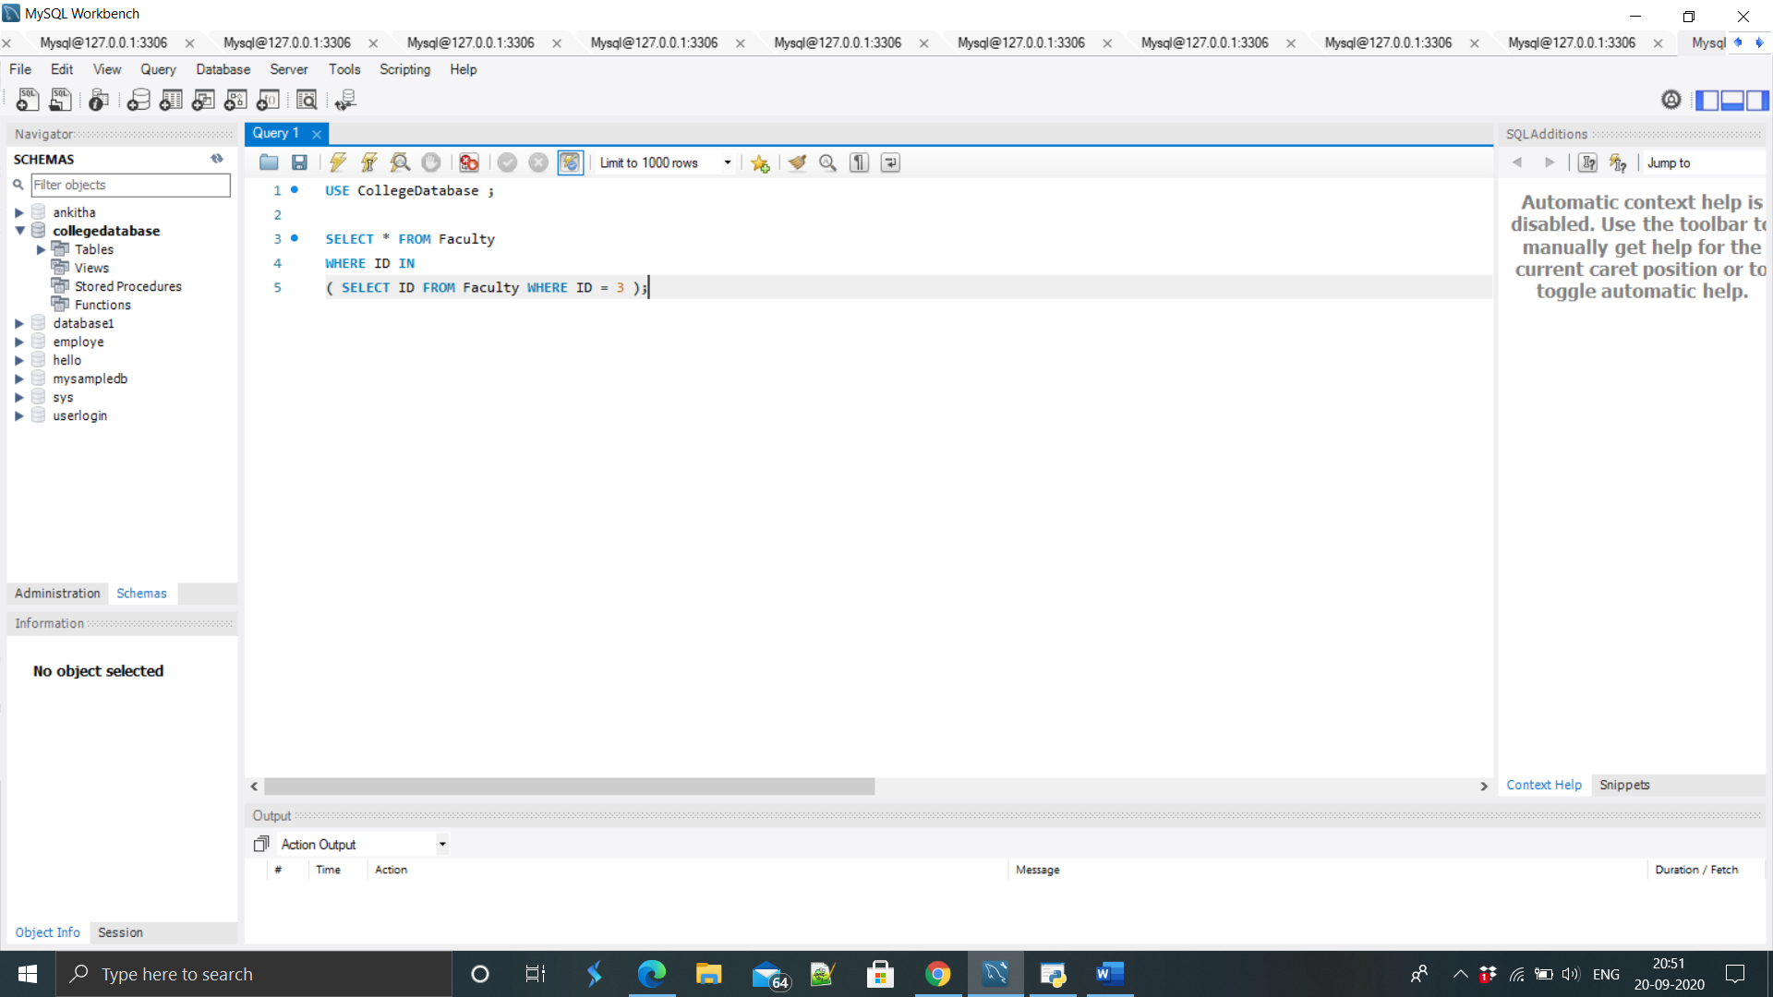

OUTPUT :

